**CareTech**

Caretaker Simulator

Game Design Document

Version 0.1

|  |  |  |  |
| --- | --- | --- | --- |
| **Version** | **Author** | **Date** | **Comments** |
| V0.1 | A.G Mureseanu | 09/03/2023 | Initial Version |
| V1.0 | A.G Mureseanu | 27/04/2023 | Updated paragraphs to contain more in-depth information about the goal of the game and mechanics. |
|  |  |  |  |

Contents

**1.** **Introduction** 4

**1.1.** **Scope** 4

**1.2.** **Overview** 4

**1.3.** **Types of fun** 4

**1.4.** **Theme and Mood** 4

**1.5.** **Elevator Pitch** 5

**2.** **Specifications** 5

**2.1.** **Concept** 5

**3.** **Background** 5

**3.1.** **Setting** 5

**4.** **Game Structure/Gameplay** 8

**4.1.** **Gameplay Loop** 8

4.2. **Player** 8

**4.3.** **Actions** 8

**4.4.** **Non-Playable Characters (NPCs)** 9

**4.4.1.** **Stats** 9

**4.4.2.** **Needs/Problems** 9

4.4.3. **Schedules** 9

**4.5.** **Objective/Goal** 9

**5.** **Visuals** 10

**5.1.** **Inspirations** 10

**5.2.** **Moodboard** 13

# **Introduction**

This document specifies a design for the gameplay and feel of an educational game with the title “CareTech”. The intended use of the game is to teach students of health and wellbeing about how to use caretaker specific technology in a “normal way at the office” way and get them acquainted with it.

## **Scope**

The scope of the project includes a feature complete but content incomplete MVP of the educational game that will be tested by ROC PIT as a teaching tool.

## **Overview**

|  |  |
| --- | --- |
| Genre | Social Simulation |
| Platform | Desktop |
| Target Audience | Students of health and wellbeing |

## **Types of fun**

* Discovery
  + Players discover the needs of the NPCs.
  + Players discover and learn about different technologies and tools.
* Challenge
  + Players will be challenged to do a good job and do it fast.
* Griefing
  + Many other games in the simulation genre attract players for this type of fun, where the player purposefully tries to make the life of the inhabitants of the world as dark and miserable as possible (Ex: RimWorld being known as “War Crime Simulator”).

## **Theme and Mood**

**Theme:**

Social, helping people, understanding problems.

**Mood:**

Serious, friendly, vibrant colors, happy tone.

## **Elevator Pitch**

CareTech is a game that gets inspired by the uniqueness of the NPCs of the world of Dwarf Fortress, specifically the uniquely generated NPCs and Schedules, and plans to put them in a housing environment like Phasmophobia, but more light-hearted, where the player will use first person controls to take care of the patients like the curing of the patients from Two-Point Hospital.

**Inspirations:**

* Dwarf Fortress
  + Dwarf Fortress is a unique kind of game where the player takes care of and builds a colony of dwarves. In this colony, each dwarf has his own personality, stats, history, etc. CareTech takes inspiration from the NPC systems to make NPCs look alive.
* Phasmophobia
  + Phasmophobia provides a realistic and interactable sub-urban environment, where the player can turn off lights, move items and furniture, etc. CareTech takes inspiration from this kind of environment, but a scary house would not fit the theme and mood of the game, so CareTech will go into a more light-hearted direction.
* Two-Point Hospital
  + In this game, the player needs to find out what is wrong with patients and treat them using the correct tools. CareTech wants to provide a similar experience to that of Two-Point Hospital when it comes to treating the needs of the NPCs.

# **Specifications**

## **Concept**

The aim of CareTech is to provide a virtual playground where the students of health and wellbeing can learn about caretaker specific technology using textbook material and detective-like skills in order to make the NPCs happy.

# **Background**

## **Setting**

The setting of the game will be located in a nursing home, as shown in the images below. More environments could/might be added in future developments of the game if the game will continue development after the prototype.

Figure 1: Nursing home.

Figure 2: House Plan of a nursing home.

# **Game Structure/Gameplay**

## **Gameplay Loop**

The gameplay loop consists of the player reacting to the events and needs of the NPCs present in the game for an in game (10-15 minutes) day. (Example: a NPC that forgets to come to breakfast/lunch/dinner should have a Robot Tessa - [https://www.zorgvannu.nl/innovaties/zorgrobots-voor-dagstructuur](https://www.zorgvannu.nl/innovaties/zorgrobots-) installed in his room)

The game will feature three types of rewards:

* Rewards of Praise
  + The player will be praised by the game and the NPCs when doing the correct actions and consoled by them if doing stuff incorrectly.
* Rewards of Sensory Feedback
  + The NPCs will visually appear happier/sadder if the player correctly/incorrectly reacts to their needs.
* Rewards of Glory
  + Based on the performance of the player, different trophies/achievements can be unlocked.

The game will have a play time of 70-100 minutes (7 in game days).

## **Player**

The player character will be controlled using mouse and keyboard in a first-person perspective. The player can interact with the technologies and tools available in the game and carry tools in his hands.

|  |  |
| --- | --- |
| **Key(s)** | **Action** |
| WASD | Movement |
| Mouse | Look Around |
| Left Click | Pick Up, Interact |
| Right Click | Drop Item |

## **Actions**

The player will be able to interact with the NPCs/Technologies based on the event, needs of the NPC and tools that are available.

The interaction consists of the player being in the proximity of the interactable object/location/NPC and pressing the interact button.

The interactions that can happen are specific per instance of the interactable.

## **Non-Playable Characters (NPCs)**

The interaction and events in the game are all based around NPCs. Since the NPCs are the biggest part of the game, they need to be complex.

The goal when designing the NPCs is to make them feel alive and semi-realistic. In order to achieve this, a few extra systems containing data will be implemented.

### **Stats**

The NPCs will have visually accessible stats such as hunger, the need to go to the toilet, sleep, etc. They will react to the stats as necessary. (Example: going to drink water when thirsty). The stats will be randomized within certain thresholds for every NPC.

### **Needs/Problems**

Each NPC will have specific needs that might trigger events to which the player needs to respond. These needs link to issues that lead to a caretaker specific situation. As for an example, an NPC that forgets to show up during group lunch will have a Robots Tessa installed in his room, in this case the problem is “forgetfulness”, and the need is “reminder”.

### **Schedules**

Each NPC will have a semi-randomized schedule each day, taking stats and needs into account.

Schedules might abruptly change based on events.

## **Objective/Goal**

The objective of the game consists of the player taking care of the needs of the nursed NPCs by learning about and using technology.

The cases which will take place during the gameplay are as follows:

* Robot Tessa
  + The NPC does not show up to activities such as breakfast, lunch, dinner, movie night, etc.
* Hir Airbag
  + The NPC will show a slightly different animation that showcases the inability to balance, getting worse over time.
* Bed Sensor
  + The NPC will reverse his sleeping schedule.
* Pill Dispenser
  + The NPC will forget to take his pills and leave them around the room.
* E-Bike game
  + The NPC will spend most of his free time on the sofa/bed and will not move around.

The goal of the game is to spend 7 days ( ~70 minutes) taking care of the needs of the NPCs by using the technology available.

# **Visuals**

## **Inspirations**

* **Phasmophobia**

Phasmophobia is a horror game in which the player is tasked with finding out what type of ghost haunts a **house.** The location in which the game takes place is usually a family house. For the game CareTech, the location will be a **nursing home**, which has a similar base.

The inspiration comes from the house design but will be changed in a low-poly non-scary mood.

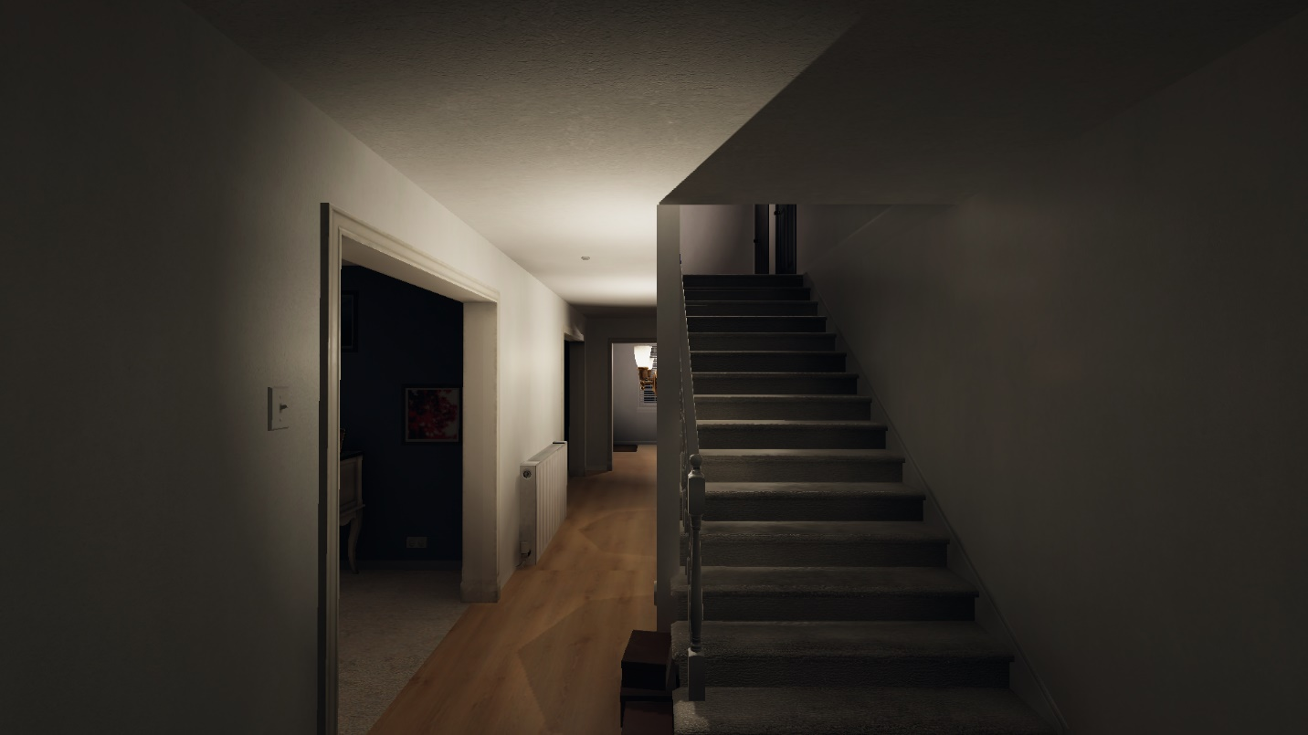

Figure 3 : Phasmophobia house

* Low Poly Games

Low Poly Games, which are games that use models containing a low amount of polygons, are a type of game that use simplistic graphics in order to force the player to use their imagination and thus, stick more with the player.

The simplicity also offers less visual clutter, which is an advantage when presenting the game to a non-gamer, such as the students of health and wellbeing.

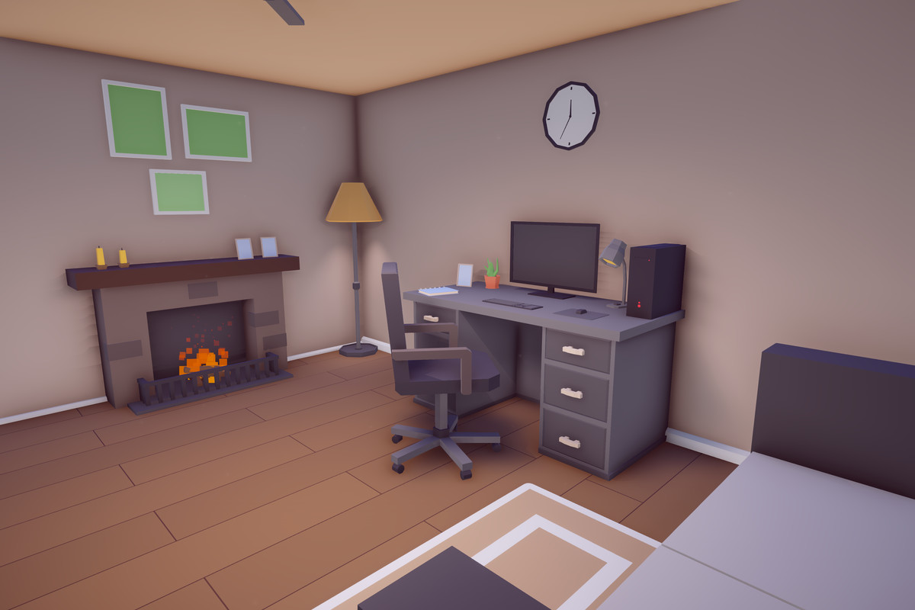

Figure 4: Low poly scene in Unity.

## **Moodboard**

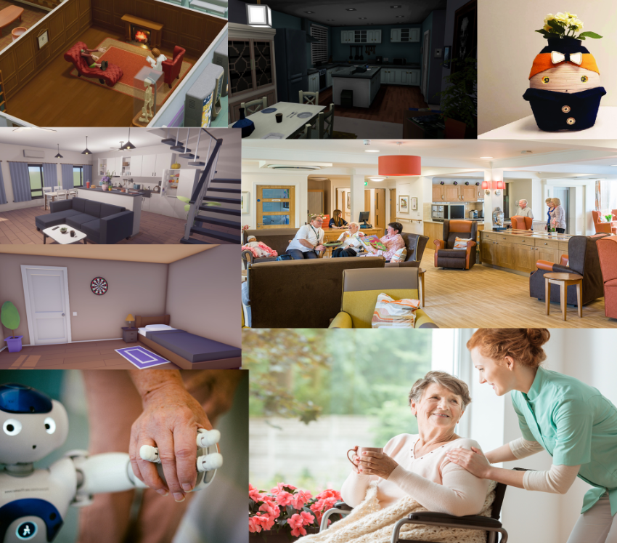

Figure 5: General Moodboard

Figure 6: Visual design moodboard